Chapter 3
Labor Productivity and Comparative
Advantage: The Ricardian Model

■ Chapter Organization
The Concept of Comparative Advantage.
A One-Factor Economy.
Production Possibilities
Relative Prices and Supply.
Trade in a One-Factor World.
Determining the Relative Price after Trade.
Box: Comparative Advantage in Practice: The Case of Babe Ruth.
The Gains from Trade.
A Note on Relative Wages.
Box: The Losses from Nontrade.
Misconceptions about Comparative Advantage.
Productivity and Competitiveness.
Box: Do Wages Reflect Productivity?
The Pauper Labor Argument.
Exploitation.
Comparative Advantage with Many Goods.
Setting Up the Model.
Relative Wages and Specialization.
Determining the Relative Wage in the Multigood Model.
Adding Transport Costs and Nontraded Goods.
Empirical Evidence on the Ricardian Model.

Summary

■ Chapter Overview
The Ricardian model provides an introduction to international trade theory. This most basic model of trade involves two countries, two goods, and one factor of production, labor. Differences in relative labor productivity across countries give rise to international trade. This Ricardian model, simple as it is, generates important insights concerning comparative advantage and the gains from trade. These insights are necessary foundations for the more complex models presented in later chapters.
The text exposition begins with the examination of the production possibility frontier and the relative prices of goods for one country. The production possibility frontier is linear because of the assumption of constant returns to scale for labor, the sole factor of production. The opportunity cost of one good in terms of the other equals the price ratio because prices equal costs, costs equal unit labor requirements times wages, and wages are equal in each industry.
After defining these concepts for a single country, a second country is introduced that has different relative unit labor requirements. Supply and demand curves relative to general equilibrium are developed. This analysis demonstrates that at least one country will specialize in production. The gains from trade are then demonstrated with a graph and a numerical example. The intuition of indirect production, that is “producing” a good by producing the good for which a country enjoys a comparative advantage and then trading for the other good, is an appealing concept to emphasize when presenting the gains from trade argument. Students are able to apply the Ricardian theory of comparative advantage to analyze three misconceptions about the advantages of free trade. Each of the three “myths” represents a common argument against free trade, and the flaws of each can be demonstrated in the context of examples already developed in the chapter. The first myth is that trade is driven by absolute advantage. This chapter clearly demonstrates that it is comparative advantage that matters. The second is the pauper labor argument, with poor countries having an “unfair advantage” in trade given low-cost labor. The chapter highlights that the gains from trade are irrelevant to the source of comparative advantage. Finally, the myth of workers in poor countries being exploited by trade is exposed by asking whether these workers would be better off without trade. As the numerical example in this chapter demonstrates, the answer is a resounding “no.”
Although the initial intuitions are developed in the context of a two-good model, it is straightforward to extend the model to describe trade patterns when there are N goods. Comparative advantage in this model is driven by relative wages between countries rather than relative prices. However, the implication that countries will export goods for which they have the lowest opportunity cost remains.
The N-good model is used to discuss the role that transport costs play in making some goods nontraded.
As transport costs rise, the gains from trade decrease, and in some cases they are completely eliminated. The chapter ends with a discussion of empirical evidence of the Ricardian model. The authors are careful to point out that, while the rather simplified model cannot explain all trade patterns, the basic prediction that countries tend to export goods for which they have a comparative advantage (high relative productivity) has been confirmed by a number of studies.

■ Answers to Textbook Problems
1. a. The production possibility curve is a straight line that intercepts the apple axis at 400 (1,200/3) and the banana axis at 600 (1,200/2).
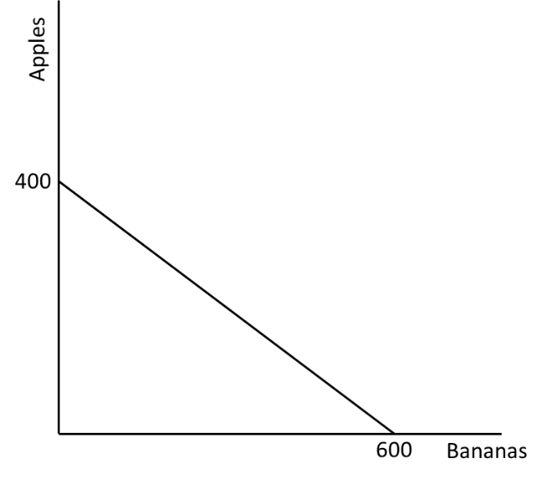
b. The opportunity cost of apples in terms of bananas is 3/2. It takes 3 units of labor to harvest an apple but only 2 units of labor to harvest a banana. If one forgoes harvesting an apple, this frees up 3 units of labor. These 3 units of labor could then be used to harvest 1.5 bananas.
c. In the absence of trade, we know that the relative price of apples (p_{A}) over the relative price of bananas (p_{B}) is equal to the ratio of the unit labor requirements for apples (a_{A}) and bananas (a_{B}). In other words, $\frac{p_{A}}{p_{B}}=\frac{a_{A}}{a_{B}}=\frac{3}{2}=1.5$. In the absence of trade, one apple will sell for 1.5 bananas.
2. a. The production possibility curve is linear, with the intercept on the apple axis equal to 160 (800/5) and the intercept on the banana axis equal to 800 (800/1).
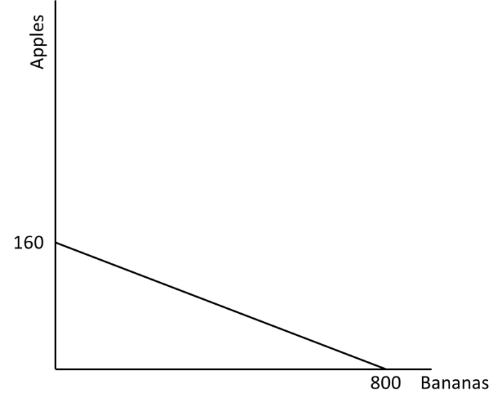
b. The world relative supply curve is constructed by determining the supply of apples relative to the supply of bananas at each relative price. The lowest relative price at which apples are harvested is 3 apples per 2 bananas. The relative supply curve is flat at this price. The maximum number of apples supplied at the price of 3/2 is 400 supplied by Home while, at this price, foreign harvests 800 bananas and no apples, giving a maximum relative supply at this price of 1/2. This relative supply holds for any price between 3/2 and 5. At the price of 5, both countries would harvest apples. The relative supply curve is again flat at 5. Thus, the relative supply curve is step shaped, flat at the price 3/2 from the relative supply of 0 to 1/2, vertical at the relative quantity 1/2 rising from 3/2 to 5, and then flat again from 1/2 to infinity.
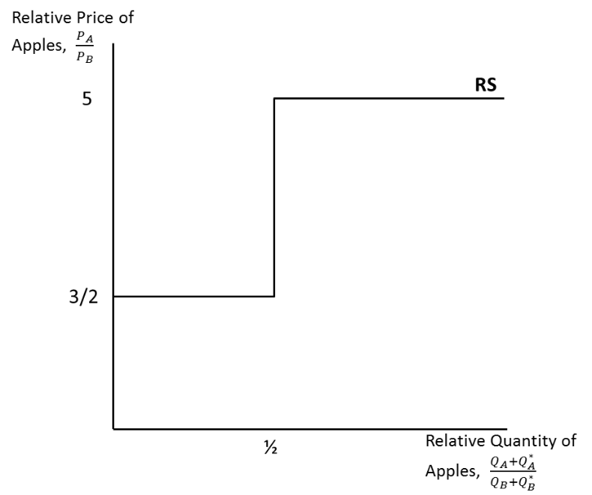
3. a. The relative demand curve includes the points (1/5, 5), (1/2, 2), (2/3, 3/2), (1, 1), (2, 1/2).
b. The equilibrium relative price of apples is found at the intersection of the relative demand and relative supply curves. This is the point (1/2, 2), where the relative demand curve intersects the vertical section of the relative supply curve. Thus, the equilibrium relative price is 2.
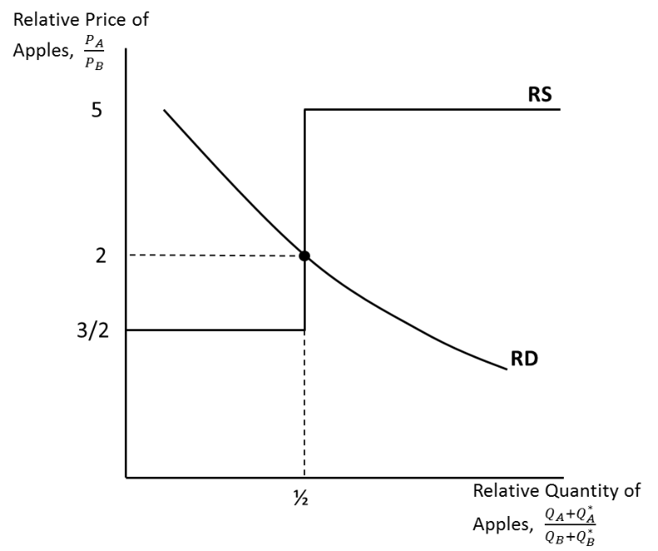
c. Home produces only apples, Foreign produces only bananas, and each country trades some of its product for the product of the other country.
d. In the absence of trade, Home could gain 3 bananas by forgoing 2 apples, and Foreign could gain by 1 apple forgoing 5 bananas. Trade allows each country to trade 2 bananas for 1 apple. Home could then gain 4 bananas by forgoing 2 apples, while Foreign could gain 1 apple by forgoing only 2 bananas. Each country is better off with trade.
4. The increase in the number of workers at Home shifts out the relative supply schedule such that the corner points are at (1, 3/2) and (1, 5) instead of (1/2, 3/2) and (1/2, 5). The intersection of the relative demand and relative supply curves is now in the lower horizontal section, at the point (2/3, 3/2). In this case, Foreign still gains from trade, but the opportunity cost of bananas in terms of apples for Home is the same whether or not there is trade, so Home neither gains nor loses from trade.
5. This answer is identical to that in Answer 3. The amount of “effective labor” has not changed because the doubling of the labor force is accompanied by a halving of the productivity of labor.
6. This statement fails to connect wages and productivity. Though wages in China are lower than they are in the United States, the reason for this is that productivity is significantly lower in most industries in China. The diagram in the box titled “Do Wages Reflect Productivity?” shows that Chinese productivity is less than 10% that of the United States, corresponding to much lower wages in China. Thus, even though wages are higher in the United States than they are in China, it is not clear that it is cheaper to produce all goods in China. If Chinese workers have 10% as much productivity as American workers, then it would only be cheaper to produce in China if Chinese wages are no more than 10% as large as American wages (assuming labor is the only input into production). While this may hold for some goods (those exported to the U.S.), it does not for other goods (those exported from the U.S. to China).
7. Wages in China will be determined by productivity in both the manufacturing and the service sectors. Wages are a function of labor productivity and the price of the good or service being traded. That services are generally not traded across borders does influence their price, allowing a different price to be charged in the United States as compared to China, for example. However, the presence of a service sector will still influence wages in both the manufacturing and service sectors assuming that labor is mobile between these sectors. As productivity in the service sector increases, Chinese wages will rise. Wages will also rise as the price received for manufactured goods increases with trade. Thus, wages are a function of productivity and prices in all sectors.
8. One explanation for a lower cost of living in China is that there is high labor productivity in the service sector. This high productivity level will cause the price of services in China to be significantly lower than those in the United States or Europe. Because services are generally non-tradable, these price differences can persist even with international trade. If services could be traded, then we would expect the price of services to rise in China and fall in the United States and Europe. However, most services are non-tradable and thus living costs in China tend to be lower than in the United States and Europe.
9. The gains from trade increase as the share of nontraded goods decreases. As more and more goods become traded, more opportunities for maximizing comparative advantage through specialization are realized and more countries will be able to focus resources on those industries in which they have the highest productivity.
  - The world relative supply curve in this case consists of a step function, with as many “steps” (horizontal portions) as there are countries with different unit labor requirement ratios. Any countries to the left of the intersection of the relative demand and relative supply curves export the good in which they have a comparative advantage relative to any country to the right of the intersection (the opposite holds for the good in the denominator of relative price/quantity). If the intersection occurs in a horizontal portion, then the country with that price ratio produces both goods.

